### ***Course: CSC14003 – Introduction to Artificial Intelligence***

### ***Class 22CLC – Term Ii/2023-2024***

FINAL EXAMINATION REVIEW

**Question 01.** (Adapted from Prof. Ziv-Bar Joseph, Carnegie Mellon University, Course 10-701 Machine Learning materials.) NASA wants to discriminate Martians (M) from Humans (H) based on these features (attributes): Green ∈ {𝑁, 𝑌}, Legs ∈ {2, 3}, Height ∈ {𝑆, 𝑇}, Smelly ∈ {𝑁, 𝑌}. Your available training data is as follows (N = No, Y = Yes, S = Small, T = Tall). Note that it is just a made-up problem for the exercise, anything can happen!

| # | Height | Green | Legs | Smelly | Target: Species0 |
| --- | --- | --- | --- | --- | --- |
| 1 | S | Y | 3 | Y | M |
| 2 | T | Y | 3 | N | M |
| 3 | S | Y | 3 | N | M |
| 4 | T | Y | 3 | N | M |
| 5 | T | N | 2 | Y | M |
| 6 | T | Y | 2 | Y | H |
| 7 | S | N | 2 | N | H |
| 8 | T | N | 3 | N | H |
| 9 | S | N | 3 | N | H |
| 10 | T | N | 3 | N | H |

Build an ID3 decision tree classifier from the above training dataset. Attributes are evaluated using Information Gain. Ties are broken such that an attribute with earlier alphabetical order is preferred.

1. Present the calculations required to choose the attribute for the root node.

|  | Target | Height | | Green | | Legs | | Smelly | |
| --- | --- | --- | --- | --- | --- | --- | --- | --- | --- |
| S | T | Y | N | 2 | 3 | Y | N |
| H |  |  |  |  |  |  |  |  |  |
| AE |  |  | |  | |  | |  | |
| IG |  | |  | |  | |  | |

The root is **____________________________________**

1. Present the calculations required to choose the attribute for the root’s left branch.

|  | Target | Height | | Legs | | Smelly | |
| --- | --- | --- | --- | --- | --- | --- | --- |
|  |  |  |  |  |  |
| H |  |  |  |  |  |  |  |
| AE |  |  | |  | |  | |
| IG |  |  | |  | |  | |

The left child of the root is **_____________________________________**

1. Present the calculations required to choose the attribute for the root’s right branch.

|  | Target | Height | | Legs | | Smelly | |
| --- | --- | --- | --- | --- | --- | --- | --- |
|  |  |  |  |  |  |
| H |  |  |  |  |  |  |  |
| AE |  |  | |  | |  | |
| IG |  |  | |  | |  | |

The right child of the root is **_____________________________________**

1. Draw the complete ID3 decision tree

**Question 02.** From the sentence "Heads I win, tails you lose," prove that "I win" by using propositional logic refutation resolution.

1. Represent the given sentence in propositional logic using only the following prepositions: Head (the coin’s head), Tail (the coin’s tail), IWin (I win), and YouLose (you lose)
2. Add some general knowledge axioms about coins, winning, and losing.
3. Convert the propositional logic sentences to their CNF equivalents.
4. Apply propositional refutation resolution to prove the above conclusion.

**Question 03.** Consider the following KB.

| 1. Buffalo(x) ∧ Pig(y) → Faster(x,y) 4. Buffalo(Bob)  2. Pig(y) ∧ Slug(z) → Faster (y,z) 5. Pig(Pat)  3. Faster(x,y) ∧ Faster (y, z) → Faster(x,z) 6. Slug(Steve) |
| --- |

Use first-order logic forward chaining to prove **Faster(Bob, Steve)**. If several rules apply, use the one with the smallest number. Show the chaining process step by step, using the numbering of the sentences to identify how you are using the rules and facts in the KB. For either presentation method, you will need to **indicate the unifications**.

|  |
| --- |

**Question 04.** Consider the following English sentences

1. Every child loves Santa.

2. Everyone who loves Santa loves any reindeer.

3. Rudolph is a reindeer, and Rudolph has a red nose.

4. Anything which has a red nose is weird or is a clown.

5. No reindeer is a clown.

6. Scrooge does not love anything which is weird.

1. Build a FOL knowledge base from the above sentences, using only given predicates.

CHILD(x): “x is a child” LOVES(x, y): “x loves y”

REINDEER(x): “x is a reindeer” REDNOSE(x): “x has red nose”

WEIRD(x): “x is weird” CLOWN(x): “x is a clown”

1. Convert the propositional logic sentences to their CNF equivalents.
2. Apply propositional refutation resolution to prove that “Scrooge is not a child.”

**Question 05.** Rewrite the following sentence in first-order logic.

Politicians can fool some people all of the time, and they can fool all people some of the time, but they can’t fool all of the people all of the time.

using only the predicates given below.

Politician(x): x is a politician Person(x): x is a person

Time(t): t is a time period Fool(x, y, t): x fools y at time t

**Problem 06.** Consider the multi-layer percceptron shown below.

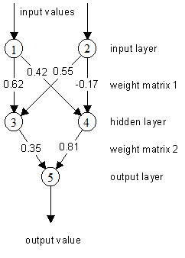

The network parameters setting is as follows.

* The set of weights are

w1 = 0.62 w2 = 0.42 w3 = 0.55 w4 = -0.17 w5 = 0.35 w6 = 0.81

* There is no bias. There is no threshold.
* Learning rate is set to 0.25.
* Sigmoid activation function

1. Compute the output values for all the hidden and output neurons when input signals come to neuron 1 and 2 are **both 1s** and output signal is 1.

| Neuron | 3 | 4 | 5 |
| --- | --- | --- | --- |
| Output |  |  |  |

1. Adjust the weights according to the computed values above.

| Weights | w1 | w2 | w3 | w4 | w5 | w6 |
| --- | --- | --- | --- | --- | --- | --- |
| Values |  |  |  |  |  |  |

**Question 07.** In the network shown below, all the units have binary inputs (0 or 1), unipolar step functions and binary outputs (0 or 1). The weights for this network are w31 = 1, w32 = 1, w41 = 1, w42 = 1 and w43 = −2. The threshold of the hidden unit (3) is 1.5 and the threshold of the output unit (4) is 0.5. The threshold of both input units (1 and 2) is 0.5, so the output of these units is the same as the input.

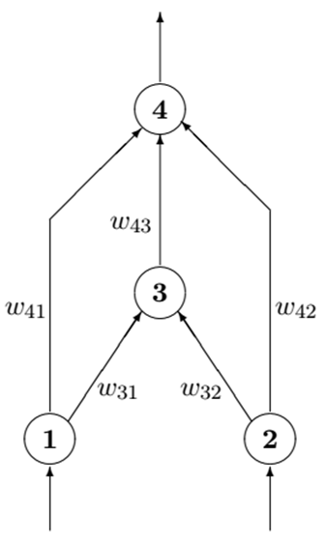

Which Boolean functions can be computed by this network? Justify your answer by showing detailed calculations.

| 1 | 2 | 3 | 4 |
| --- | --- | --- | --- |
|  |  |  |  |
|  |  |  |  |
|  |  |  |  |
|  |  |  |  |